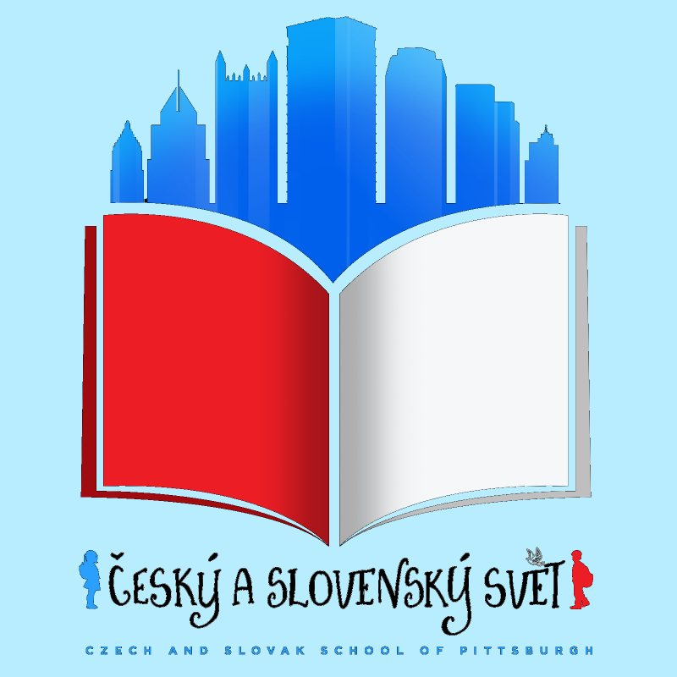

CESKY A SLOVENSKY SVET – CZECH AND SLOVAK SCHOOL OF PITTSBURGH
STUDENT ENROLLMENT FORM -2018/2019

Student’s Full Name_______________________________________________________
Date of Birth (mm/dd/yyyy) _________________________ Gender _________________
Student’s Age as of September 15th _________________________________________________
Address__________________________________________ Apt. # __________________
City________________________________ State___________ Zip __________________

Student's level of Czech/or Slovak language (circle one):
1. Speaks fluently and understands everything age appropriate
2. Understands everything age appropriate, does not speak
3. Understands some, does not speak
4. Understands very little to none, does not speak

Mother's Full Name ________________________________________________________
Address_________________________________________ Apt. # __________________
City__________________________________ State__________ Zip ______________
Home Phone # ____________________________ Cell Phone # _____________________
E-mail __________________________________________________________________

Father's Full Name ________________________________________________________
Address______________________________________________ Apt. # ______________
City_______________________________ State______________ Zip ______________
Home Phone # ________________________ Cell Phone # ________________________
E-mail __________________________________________________________________
Siblings (Please list names, DOB and enrollment status)
________________________________________________________________________
Student’s Name _____________________________________________ ______________

My child may be released to the person(s) signing this agreement and/or to the following designated person(s):
Name, Address, Relationship
__________________________________________________________________________________
__________________________________________________________________________________
__________________________________________________________________________________

Persons to contact in case of emergency, when parents cannot be reached:
Name, Home Phone #, Cell Phone #, Relationship
__________________________(______)______________(______)____________________________
__________________________(______)______________(______)____________________________
__________________________(______)______________(______)____________________________

Medical information
Child's Physician or Clinic's Name, Telephone #, Insurance Policy/Group #
_________________________________(______)__________________________________________
Does your child suffer from any allergies (food, beverages, medication, insect bites/stings)? _________
___________________________________________________________________________________
List any illnesses, injuries, hospitalizations within last 12 months:
___________________________________________________________________________________
List any medications your child is currently taking: ___________________________________________
Does your child have any medical condition we should be aware of? ____________________________
___________________________________________________________________________________
Is there any other information we need to have about your child (special needs, behavior)? __________
___________________________________________________________________________________

______________________________________________________________________________ PRINT NAME MOTHER’S SIGNATURE DATE
______________________________________________________________________________ PRINT NAME FATHER’S SIGNATURE DATE
Student’s Name ____________________________________________________________________

CONSENT FOR EMERGENCY MEDICAL ASSISTANCE
If at any point my child requires urgent medical treatment while at Czech World – Czech School of Pittsburgh (further only Czech World), provided that I or the emergency contact listed above cannot be contacted personally, I hereby give permission to the doctor or designated person to make any decision that may prove necessary, including calling 911.
Parents’ Initials ____________________

RIGHT TO USE IMAGES
I understand that Czech World/ Friends of VIA may produce or participate in video, motion picture, audio recording, web pages, still photographs, broadcast, social media, and/or other publication which may involve the use of student's images, video or voice. Such productions will be used for non-commercial education, exhibition, or promotional material and will not be sold for any reason. They may be copied copyrighted, edited, and/or distributed by Czech World/ Friends of VIA, in the manner described above. By checking YES, and signing below, I grant Czech World/ Friends of VIA, the right to use and re-use, in any manner, the video, motion picture, audio recording, web pages, still photographs, broadcast, social media, and/or other publication described above containing my child(ren)'s image or voice named herein. I waive the right of prior approval and herby release Czech World/ Friends of VIA, its agents or its designees from any and all claims for damages or remuneration of any kind based on the use of said materials. I have read the forgoing and fully and completely understand the contents thereof and accept or reject these terms and conditions as indicated below:
____________YES or ____________NO Parents’ Initials ____________________

SHARING CONTACT INFORMATION
To facilitate car pools, contact between classmates and social interaction among school families, Czech World may share contact information within the school community. Distribution is limited to Czech World families and staff for internal school use only. We will not share your information with any third party groups. If your family does not wish to have contact information shared in this way, please indicate by checking DO NOT to the following statement (this will not affect contact directly from school staff).
_____DO or ____DO NOT share our contact information. Parents’ Initials ____________________

NOTICE OF NONDISCRIMINATORY POLICY AS TO STUDENTS
Czech World admits students of any race, color, religion, national and ethnic origin to all the rights, privileges, programs, and activities generally accorded or made available to students at the school. It does not discriminate on the basis of race, color, religion, national and ethnic origin in administration of its educational policies, admissions policies, scholarship and loan programs, and athletic and other school-administered programs.
Parents’ Initials ____________________

______________________________________________________________________________ PRINT NAME MOTHER'S SIGNATURE DATE

______________________________________________________________________________ PRINT NAME FATHER’S SIGNATURE DATE
WAIVER OF LIABILITY

Student’s Full Name _______________________________
Date of Birth (mm/dd/yyyy) _________

Czech World is an initiative of Friends of Via, a 501(c)(3) nonprofit organization registered in the state of Pennsylvania. In accordance with guidelines approved by Friends of Via, and as a condition of enrollment in the Czech World program, I hereby agree to the following:
I understand and agree that, as a condition of my child(ren) being admitted to Czech World, I shall not hold liable Czech World/Friends of VIA, their employees, directors, officers, volunteers or affiliates for any injury which may occur in connection with the activities of Czech World, before, during, or after school hours, or involving any event, gathering, or occasion that I and/or my child(ren) attend(s) as a result of our connection with Czech World.
I am aware that by signing I have agreed to assume full legal liability for all rights involved with participation in the Czech World program and further that I have waived certain legal rights, including my right to sue.
I am the parent or legal guardian of the child(ren) named above.
I have read and understood this form in full for the purpose of registering my child/children at Czech World.
I agree to abide by the rules and regulations of Czech World and that my child/children will do the same.

______________________________________________________________________________
PRINT NAME MOTHER’S SIGNATURE DATE

______________________________________________________________________________
PRINT NAME FATHER’S SIGNATURE DATE

CLASS SCHEDULE and location

All classes will be held on Saturdays from 10:00am -12:00 pm at the Wightman School Community Building, 5604 Solway Street, Pittsburgh, PA 15217-1264.

Fall semester: September 15, 2018 – December 9, 2018

Tuition and Payment Information

Tuition for each semester will be $80 for children 6mo-5 years and $100 for children 6-18 years.

Tuition Payment

Please make checks payable to Friends of Via.
You may mail the check to the following address or bring it with you to the first day of class on Saturday, September 15, 2018.

Friends of Via
P.O. Box 82556
Pittsburgh, PA 15218

CONTACT INFORMATION

Email: skola@czechslovakschoolpgh.org
Phone number for inquiries: 412-880-7567
Website: www.czechslovakschoolpgh.org
Facebook page: https://www.facebook.com/groups/czechschoolofpittsburgh/

OTHER INFORMATION:

Student’s Name

Provide any additional information that will help us get to know and understand your child:

What language is primarily spoken at home (with mother/with father)?

Are there any opportunities for your child to speak Czech/Slovak outside of the classroom (grandparents, friends, etc.)?

What language does your child prefer?

Any other comments or information that you believe our teachers should know?

What do you expect your child to gain from attending the school?

Thank you for completing the Student Enrollment forms! Please scan/email your completed forms to skola@czechslovakpgh.org or bring them with you to the first day of classes on Saturday, September 15, 2018 at the Wightman School Community Building, 5604 Solway Street, Pittsburgh, PA 15217-1264.We look forward to seeing you there!

